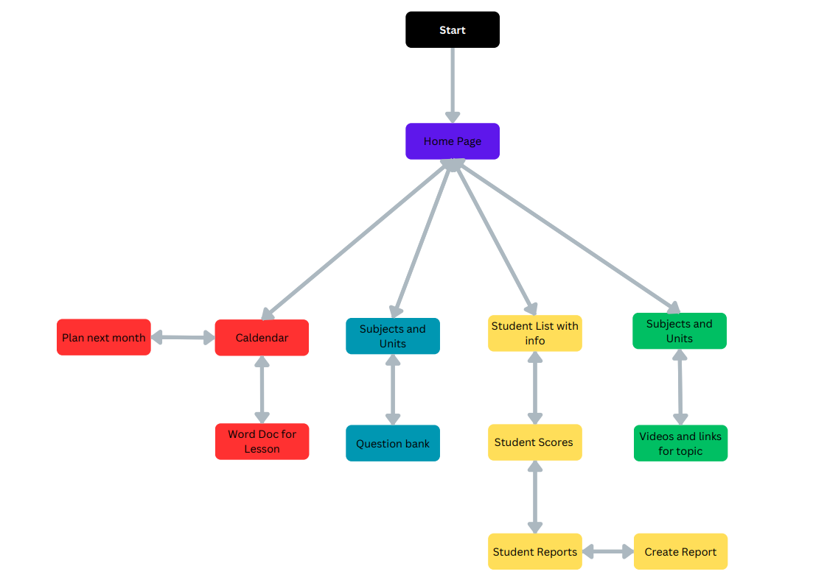

Figure 1: Shows general flow plan of program

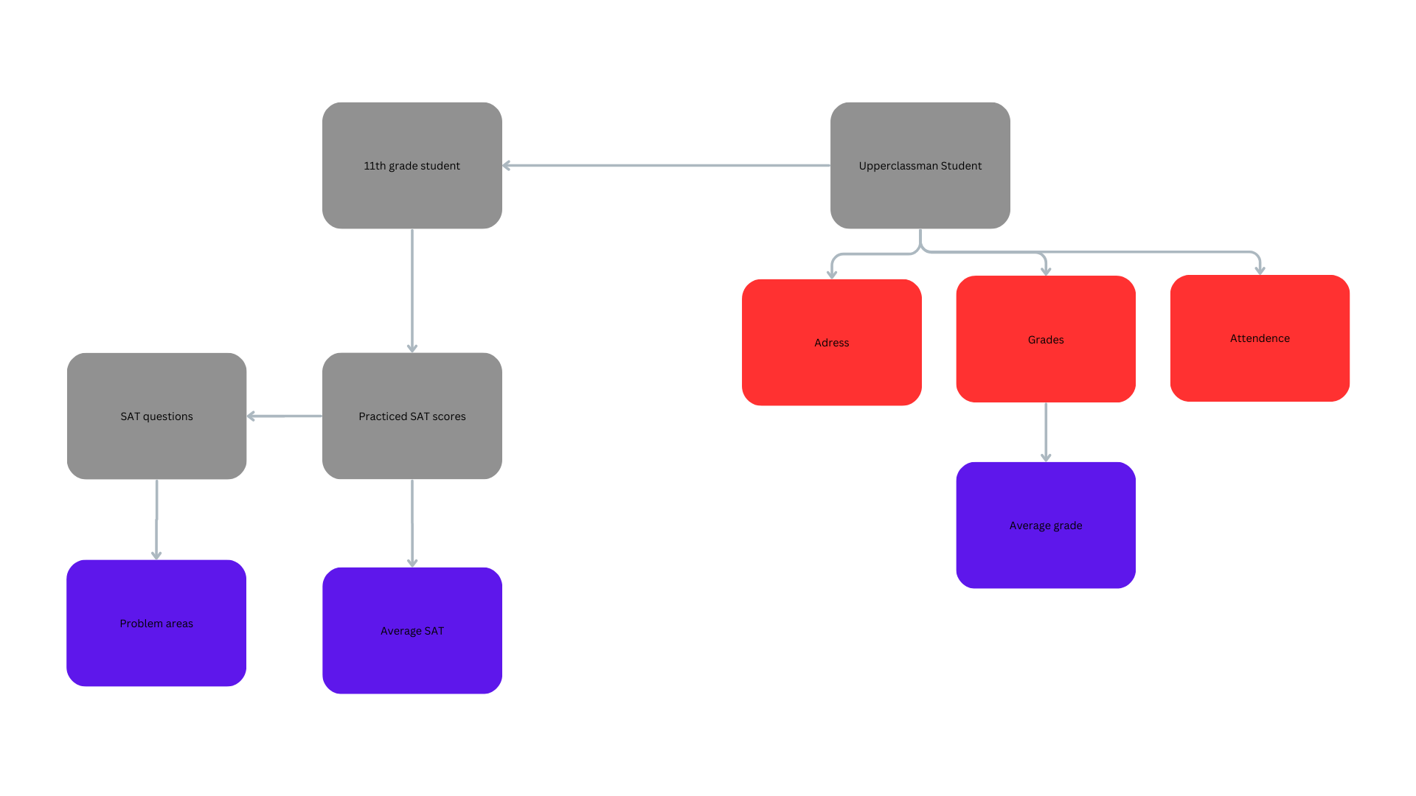  
Figure 2: Shows differences between upper and lowerclassmen

**Final GUI**

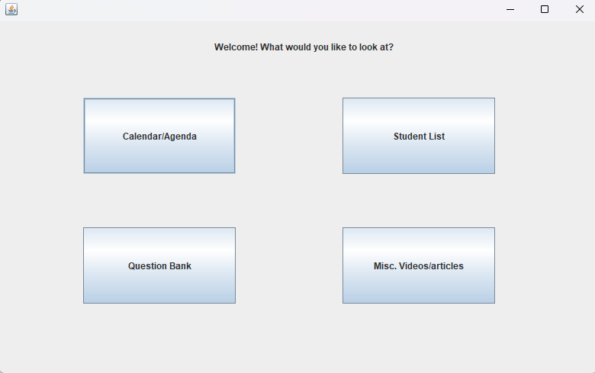

Figure 3: Shows homepage, each box leads to a certain page

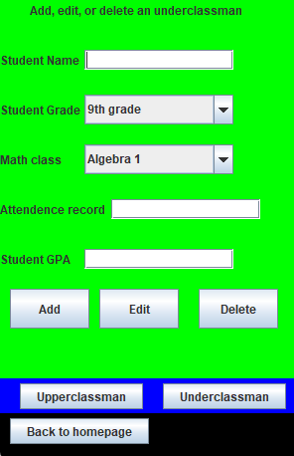

Figure 4: shows the page for adding underclassmen, distinct from the page for adding upperclassmen

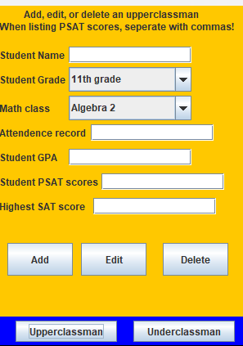

Figure 4: unlike the Underclassman page, the upperclassman page has textboxes for PSAT and SAT.

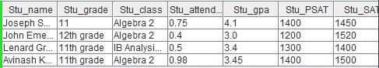

Figure 5: Layout of the table produced